# Sri Agastheeshwara Swamy Temple, Thondavada

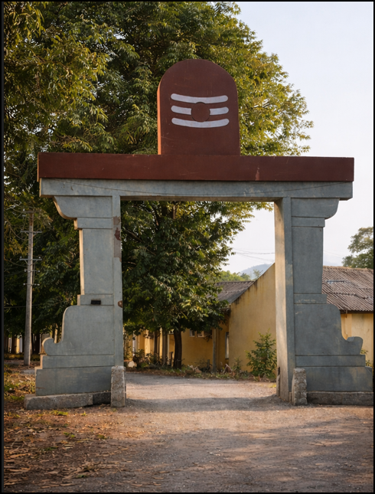 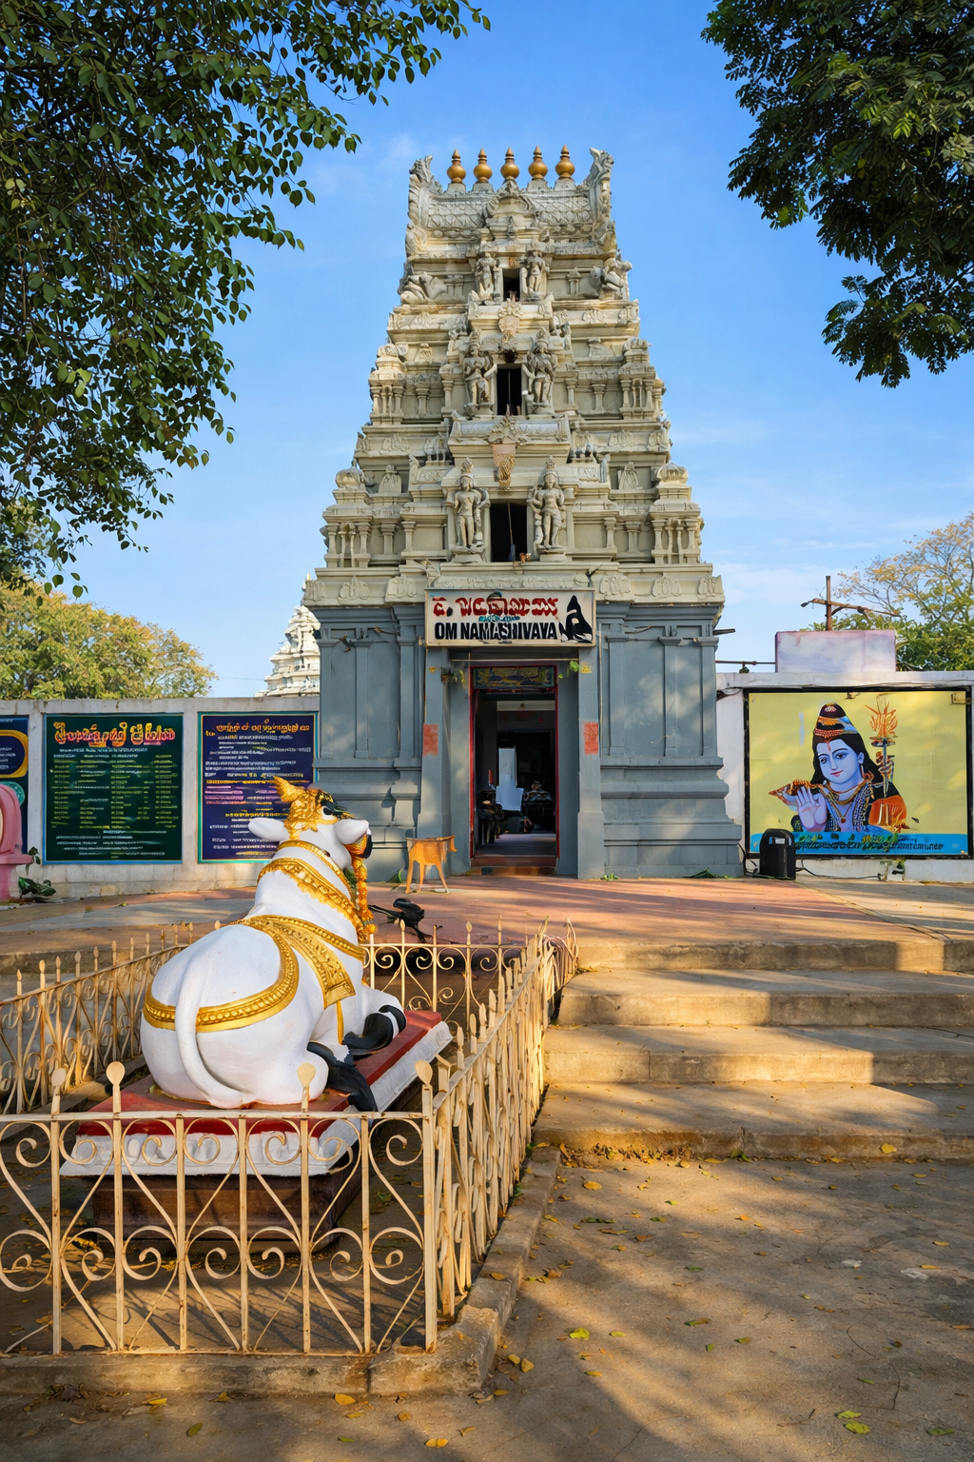 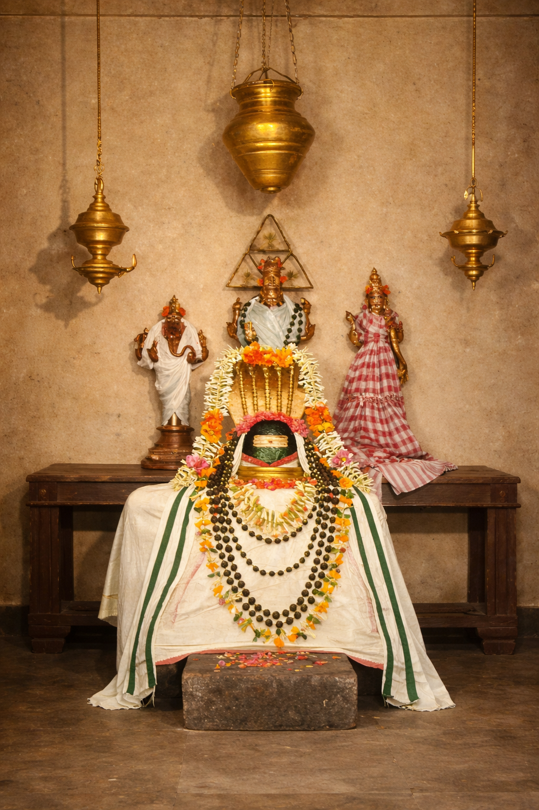

Sri Agastheeshwara Swamy Temple, Thondavada, is one of the most ancient and spiritually significant Shaiva temples in Andhra Pradesh. The temple is situated on the northern bank of the sacred Swarnamukhi River, at the foothills of the Tirumala Hills, the divine abode of Lord Sri Venkateswara. The presiding deity is Lord Shiva worshipped as Sri Agastheeshwara Swamy, with Goddess Parvati Devi revered as Sri Anandavalli Ammavaru.

This sacred site was once the hermitage (ashrama) of the great Sage Agastya Maharshi, one of the revered Saptarishis. During his southward journey undertaken at the command of Lord Shiva to restore cosmic balance, Sage Agastya established his abode here and performed intense penance for the welfare of humanity.

According to sacred tradition, during the celestial wedding of Lord Shiva and Goddess Parvati at Mount Kailasa, the earth tilted northward due to the congregation of all celestial beings. To counterbalance the earth, Sage Agastya was sent southward. On his journey, he encountered the Vindhya mountain range, which had grown excessively tall and obstructed the paths of the Sun and Moon. The sage commanded the mountains to bow down and remain so until his return. As Sage Agastya never returned, the Vindhyas remain humbled to this day.

By the divine grace of Lord Shiva, Sage Agastya was able to witness the celestial wedding at Kailasa from this very place. In those times, South India was largely arid and lacked sufficient water sources. Through his intense tapasya, Sage Agastya prayed to Lord Shiva and Goddess Ganga, resulting in the creation of several sacred rivers. One such river is the Swarnamukhi.

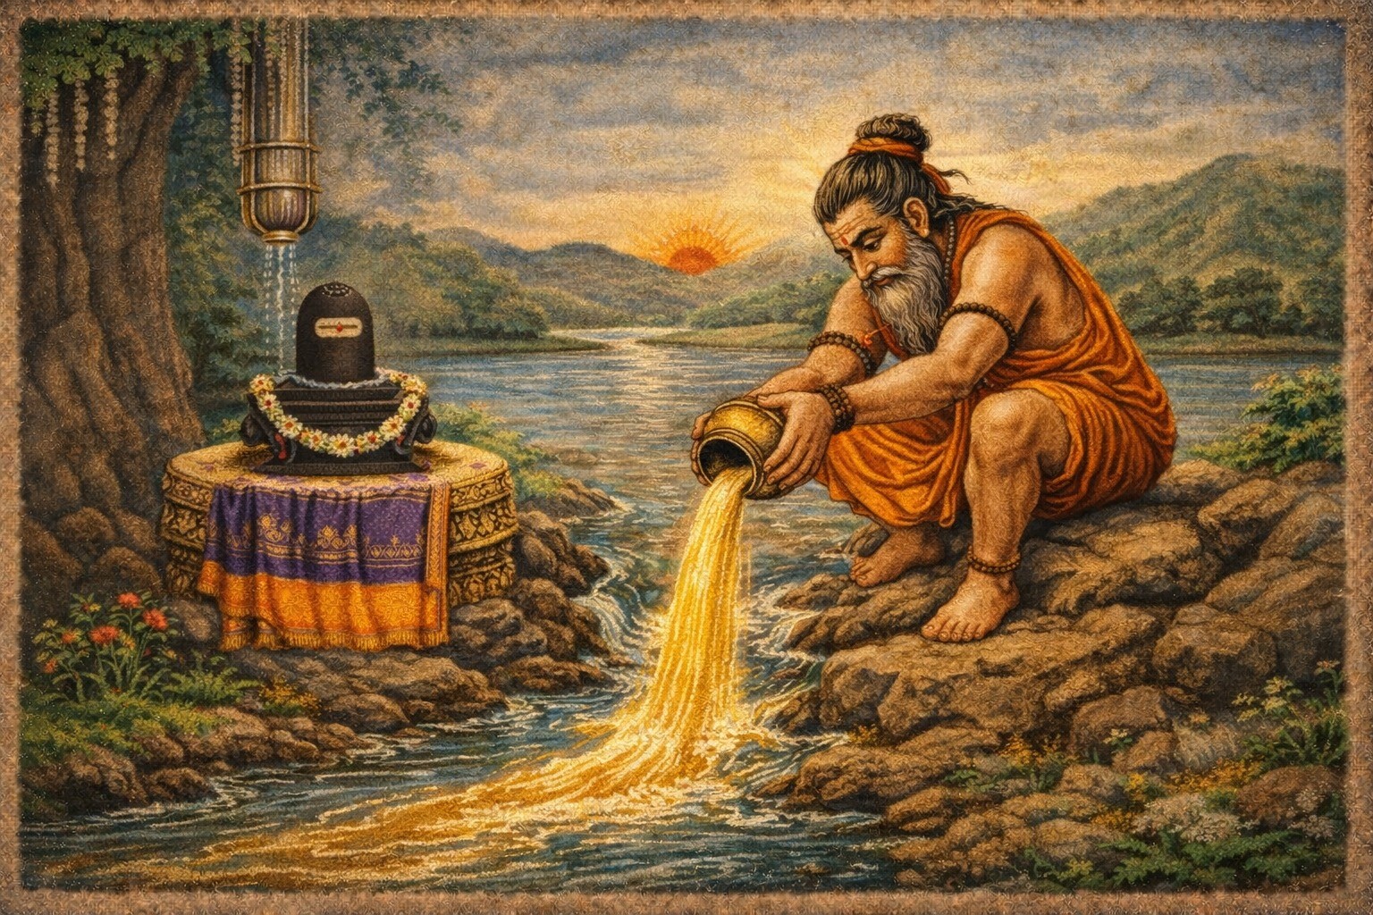

The Swarnamukhi River originates from the Mallepalli Hills near Adinepalli, about 30 km southwest of Tirupati on the Chittoor route. Flowing through the Hemanaga (Golden) Hills of Chandragiri, it acquired the name Swarnamukhi. Near the temple, the rivers Bhima and Kalyani (also known as the Vikalya River in the Puranas and associated with Sri Kalyana Venkateswara Swamy of Srinivasa Mangapuram) merge with the Swarnamukhi, forming the sacred Triveni Sangamam, also known as Mukkoti Sthalam.

After the advent of the Swarnamukhi River, this valley transformed into a serene and picturesque landscape, surrounded by the Mallepalli Hills to the south, Chandragiri Hills to the west, and the Seshachalam Hills to the north, with an open valley to the east.

One day, while bathing in the river, Sage Agastya discovered a Shiva Lingam submerged in the deep waters. He consecrated it on the riverbank and installed it as Sri Agastheeshwara Swamy. Subsequently, a temple was constructed, and Sri Anandavalli Ammavaru was installed as the consort deity.

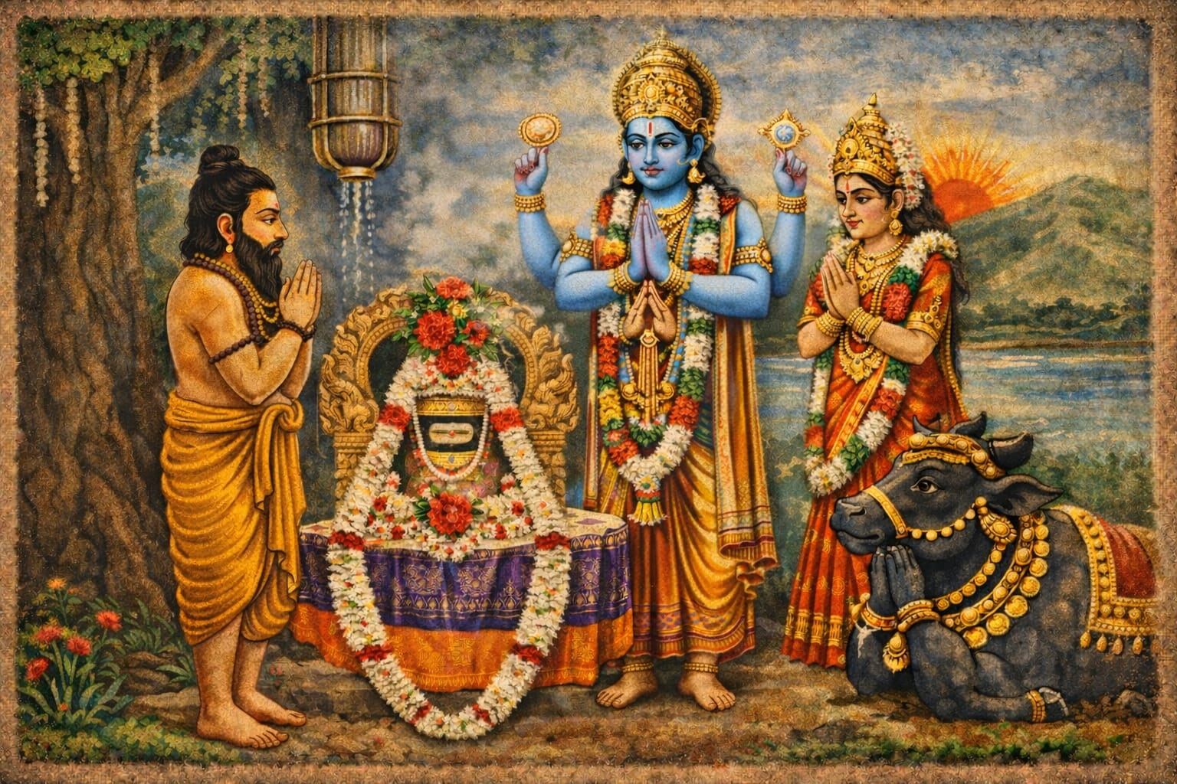

The temple holds a unique spiritual association with Lord Sri Venkateswara. After His divine marriage with Sri Padmavathi Devi at Narayanavanam, Lord Venkateswara stayed at Sage Agastya’s ashram on the banks of the Swarnamukhi River. During this period, He performed nitya poojas to Lord Shiva at this shrine. As per Sage Agastya’s advice, the Lord remained here for six months before proceeding to Tirumala, later blessing this sacred place with His divine footprints. References to this episode are found in Sri Venkateswara Ashtothara Shatanama, Sahasranama Stotras, and Sri Venkatachala Mahatyam.

Along the course of the Swarnamukhi River flourished several ancient Shaiva Kshetras alongside renowned Vaishnava Kshetras such as Tirumala, Tirupati, Tiruchanoor, and Srinivasa Mangapuram. Prominent Shaiva temples include Sri Agastheeshwara Swamy at Thondavada, Sri Parasareeswara at Yogimallavaram, Sri Parasu Rameswara at Gudimallam, Sri Kapileswara at Kapila Teertham in Tirupati, and Sri Kalahasteeswara at Srikalahasti. These temples bear architectural influences of the Pallava, Chola, and Vijayanagara dynasties, highlighting their great antiquity.

The temple architecture reflects classical Chola style with later Vijayanagara additions. A well-proportioned sanctum (garbhagriha), a three-tier Rajagopuram, spacious mandapams, and a beautifully carved 16-pillared mandapam stand as testimony to its historical and artistic heritage.

Sri Anandavalli Ammavaru is worshipped in a separate shrine within the temple complex. She is revered as the embodiment of compassion and bliss, and devotees seek her blessings for marital harmony, prosperity, and family well-being.

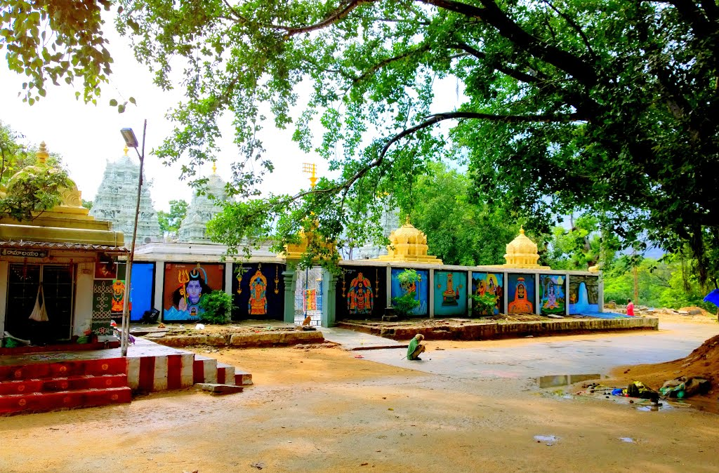

The temple is also popularly known as Sri Mukkoti Agastheeshwara Swamy Temple. Daily rituals are performed as per Shaiva Agama traditions. Maha Shivaratri, Pradosham, and Karthika Masam are observed with great devotion. The annual festival Rudrapadala Mukkoti is celebrated for three days during Kartika Pournami, featuring Annabhishekam and Annadanam on the first day, Lingodbhava Abhishekam on the second day, and Kalyanam on the third day.

Other special occasions include Ugadi, January 1st, all Karthika Mondays, and major festival days. The sacred river confluence is considered highly auspicious for holy baths, pitru tarpanam, abhishekam, and pradakshina.

Within the temple campus are shrines dedicated to Lord Ganesha, Lord Kartikeya, Kalabhairava, Sri Durga Devi, Sri Mahalakshmi, Sundareswara, and Pancha Mukheswara. Outside the compound are temples of Sri Bhadrachala Rama, Sri Krishna, and Sri Anjaneya.

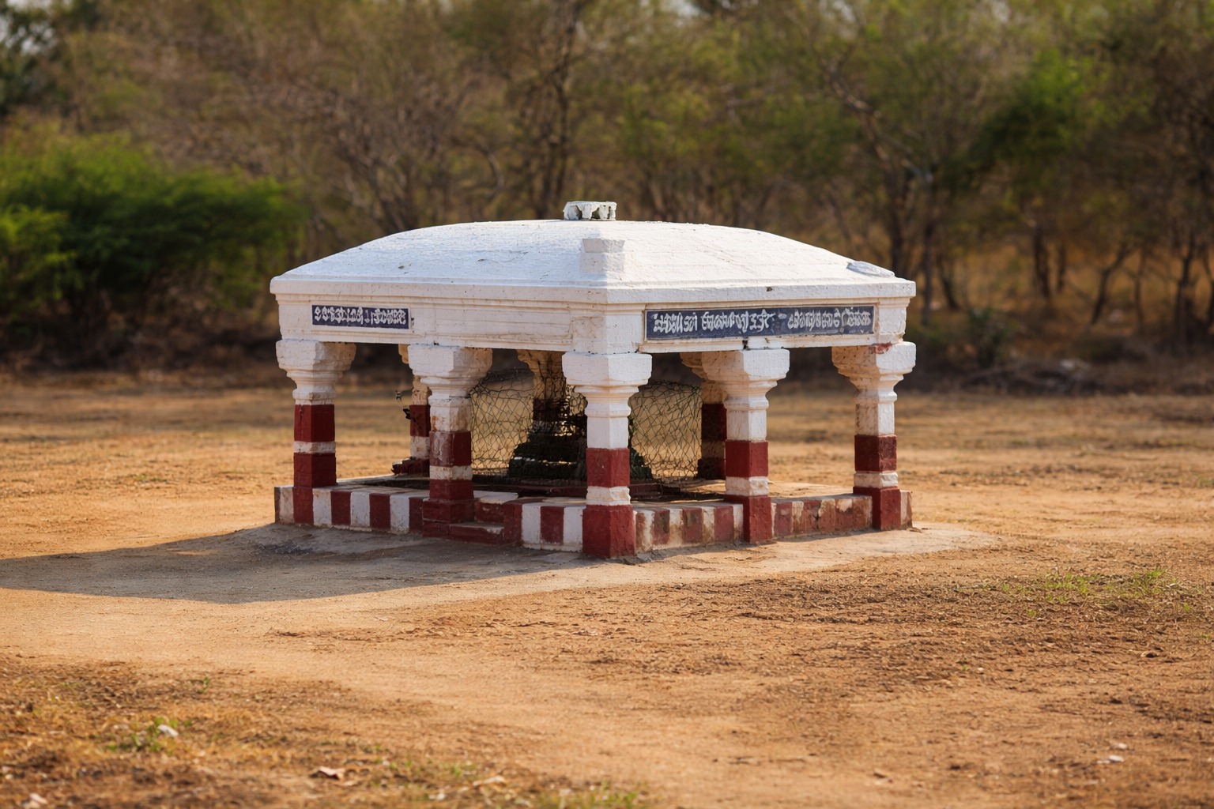

There is a river-side stone mandapam located in the middle of the Swarnamukhi River. Within this mandapam, the sacred footprint of Lord Venkateswara is enshrined. The principal deities, Sri Harihara (Siva-Kesava) and Lord Ayyappa, are also installed inside the mandapam along with the divine footprint of Lord Venkateswara.

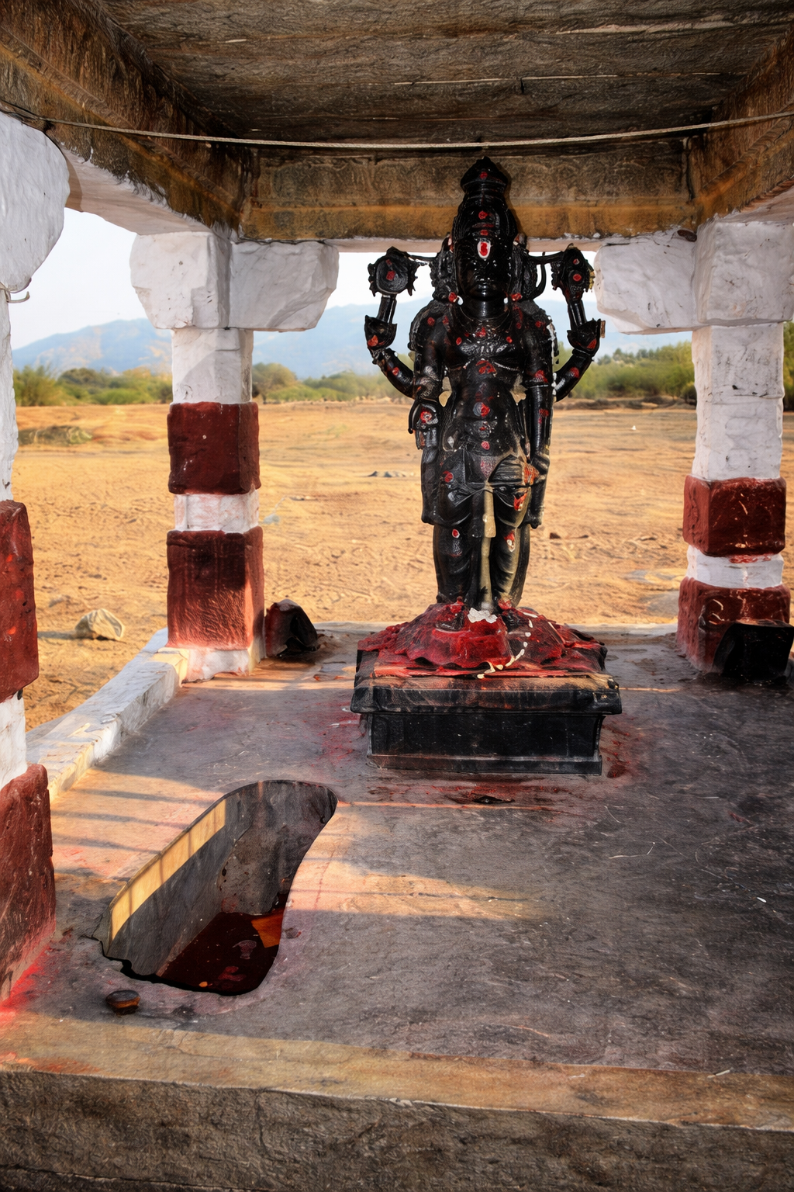

The temple is located about 10 km from Tirupati on the Tirupati–Chittoor–Bengaluru Highway, approximately 1 km before Chandragiri Fort, the historic capital of the Vijayanagara Empire. The temple is well connected by TTD local buses, APSRTC buses, AP Tourism buses, Chandragiri–Tirupati town service buses, and auto-rickshaws. Nearby places of interest include Chandragiri Fort and Museum, Srinivasa Mangapuram, Kalyani Dam, Sri Venkateswara Zoological Park, and the Regional Science Centre.

In 1909 AD, the temple was renovated by Sri Natukoti Chettiar of Tamil Nadu, who also undertook the renovation of the Sri Kalahasteeswara Temple. Subsequently, the responsibility for the temple’s maintenance was entrusted to the Mogili Reddy family, who have preserved its sanctity with deep devotion.

The Hereditary Trustee, Sri M. Chandramouli Reddy, IAS Garu, along with his brother Sri M. Sundara Rami Reddy Garu, served as Managing Trustees of Sri Mukkoti Agastheeshwara Swamy Temple for 41 years. Subsequently, their cousin Sri M. Raghurami Reddy Garu served the temple as Managing Trustee for 17 years. Through their dedicated leadership and service, the temple experienced significant spiritual and infrastructural development.